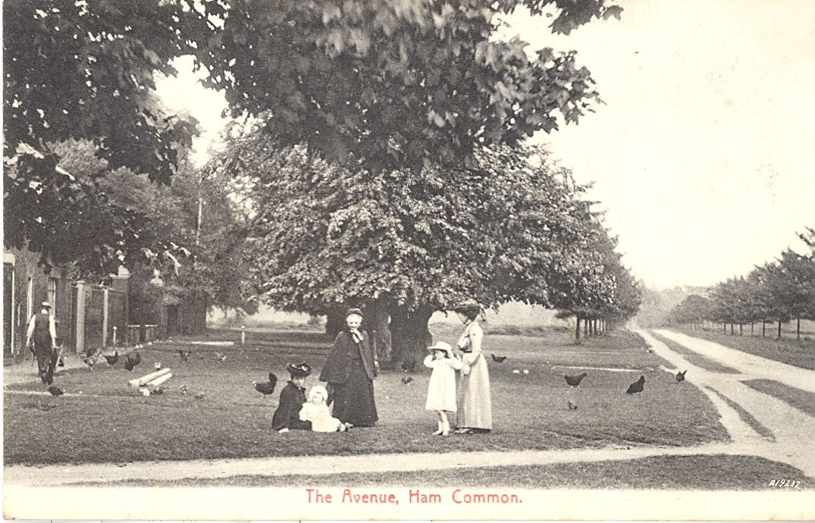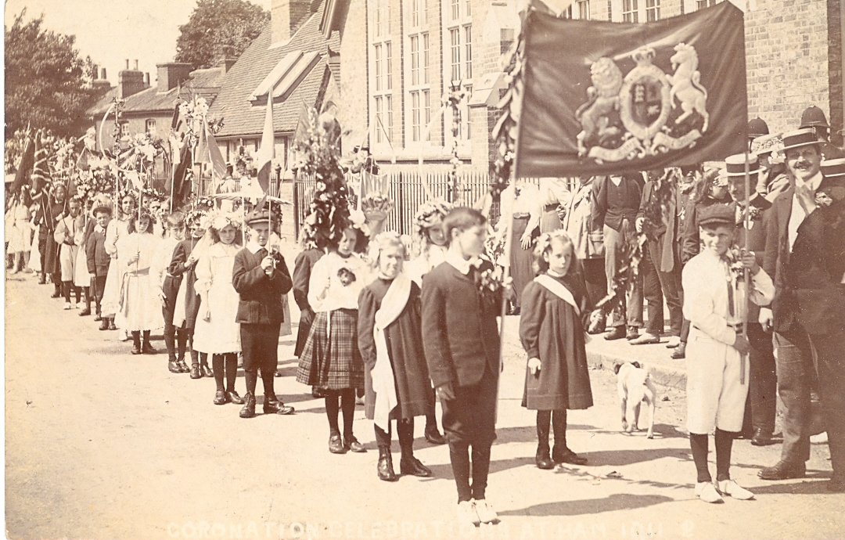“

“Ham is Where the Heart Is”

We would love you to Bring in your photos and memorabilia for copying to go on to our new website

OUR VOLUNTEERS WILL BE AT Ham Library Every Wednesday afternoon from 2-4pm

Starting 1 february

 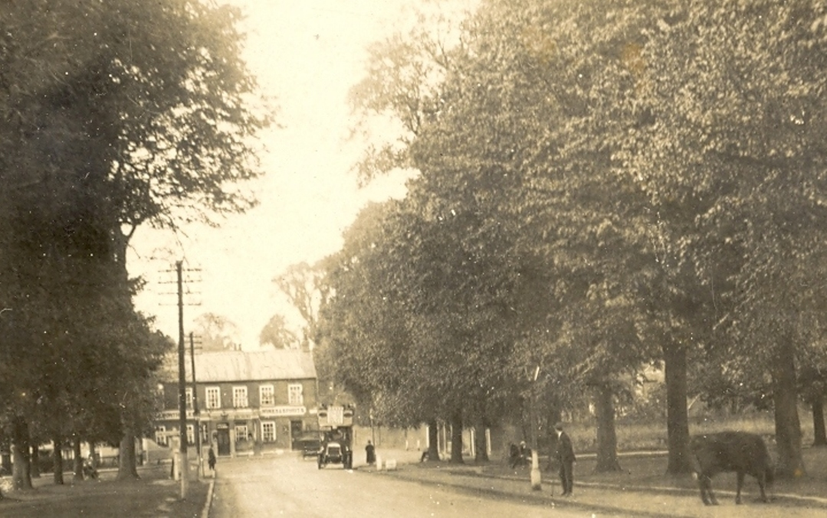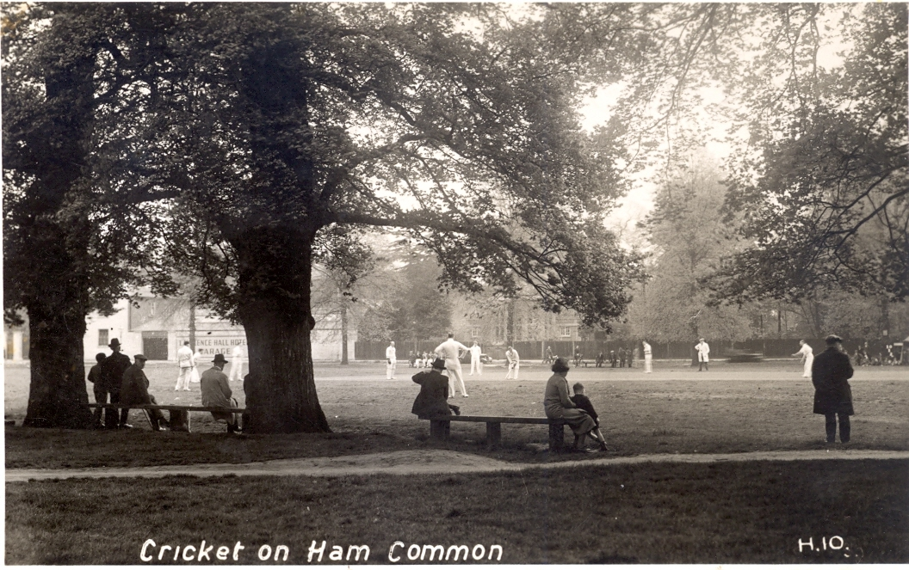

C:\Users\owner\Downloads\image002 (1).jpg  