A HOME FOR HEROES:
the 100th anniversary of the Star and Garter Home in Richmond
An illustrated talk by Dr David Blomfield

Monday 11 April 2016
at Duke Street Church, Duke St, Richmond TW9 1DH

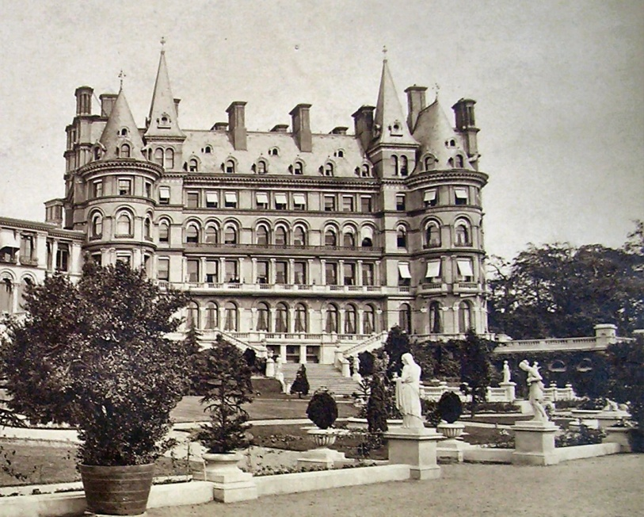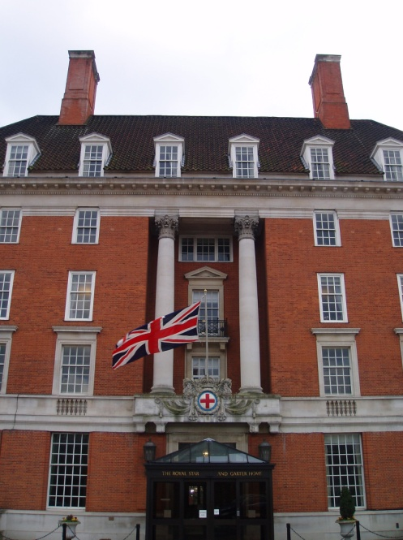
The Star and Garter Hotel, in which the Home began, and the Royal Star and Garter Home, built in the 1920s (photo on right by Carcharoth/ Wikimedia Commons)

Talk at 8pm Doors open 7:30pm
Free to members of the Richmond Local History Society
Non-members welcome
www.richmondhistory.org.uk @RLHS1985

Published in March 2016 by Richmond Local History Society, 9 Bridge Road, St Margarets, Twickenham TW1 1RE
Email: rich.hist@yahoo.co.uk The Richmond Local History Society is a registered charity, no 292907

