

**Forty Years of**

**Richmond History**

**by John Cloake** CMG

President and Founder Chairman of

the Richmond Local History Society

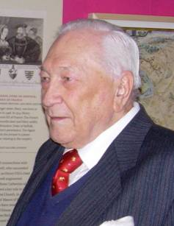

***John Cloake 1924–2014***

*An address given to*

*the Richmond Local History Society*

*on 8 December 2003*

My talk this evening is pure self-indulgence. In my 80th year, as I increasingly read about my friends' lives in the obituary columns of *The Times*, I thought I might make a pre-emptive strike – get my word in first, at least as far as the part of my life dedicated to the history of Richmond is concerned.

I am not a born Richmonder, but born and bred in Wimbledon I have memories of Richmond going back to my childhood: long walks with my mother and sister across Wimbledon Common, into the Park at Robin Hood Gate and out at Richmond Gate, through the gardens down to the river (and sometimes even along the towpath to Kew Gardens and through them to Kew Green) before taking a series of buses home; visits with my parents on Saturday afternoons to look for Staffordshire figures in the antique shops; rides through the Park on my first 'grown-up' bike, free-wheeling madly down the Hill (not one-way then) and sometimes having tea in the café at Bridge House (demolished in the 1950s).

At King's College School in Wimbledon in the 1930s I was first fired with an enthusiasm for history. I started to read about the history of Wimbledon. My history master encouraged me to tackle the vicar for permission to search through the parish chest (parish records were usually still in the keeping of the incumbents then). And so my interest in local history research was born.

We can now "fast forward" some twenty years. I went into the army. I took a history degree at Cambridge. Though it had long been my aim to join the Diplomatic Service, I was also somewhat attracted to the idea of an academic life. My beloved friend and mentor Herbert Butterfield, later Regius Professor of Modern History at Cambridge and master of my college, Peterhouse, said, "I see you helping to *make* history first; you can always write it later." So I joined the Diplomatic Service. Wherever I was posted I had a history-based project as a hobby – archaeology in Iraq (where I lived just a few hundred yards from Max Mallowan and Agatha Christie), my wife's family history in New York, old Russian churches in Moscow – and so on.

**Researching our first Richmond home**

Back from Moscow we bought our first home in Richmond in 1963. It was the Rosary in Ormond Road – a charming house built about 1699, almost unique architecturally as being (with the Hollies next-door) a back-to-back mirror-image semi-detached pair of four-storey houses, built originally not in a street but on an open site. On the day in June 1963 when our deposit was accepted I bought our first two Richmond prints as a celebration. I went into the Library to see what they could tell me about the house. There wasn't much – a few notes, including the name of its first owner, but also the statement that the Rosary and the Hollies had once been a single house. This was so patently impossible if one had ever studied the interior layout that it rather sapped my confidence. So I decided to see what I could find out for myself.

I went off to the Public Record Office in Chancery Lane to look at the Richmond manor records – and promptly discovered how fortunate Richmond historians were. As a Royal manor a splendid series of manor court rolls and books were preserved in the national archive.

With a date and a name I didn't have much difficulty in turning up a relevant entry – but it was all in mediaeval Latin. Once I had recovered from the shock and scraped up from my memory the classical Latin I had learned at school, I could make some sense of it. In a few days I had copied down and translated every item in the manor records relating to Mr Nathaniel Rawlins, haberdasher and citizen of London, and his property in Richmond. This showed that he had a little estate between Red Lion Street and the Vineyard, on which he had first built a mansion for himself (now part of Clarence House in the Vineyard) and then this pair of houses – almost certainly intended for his two grown-up daughters, but they both married and lived elsewhere. He also had a lot of other property in the town.

Now I wanted to know the descent of the property from Mr Rawlins to its purchase by us – and what had been there before the land (already with some buildings on it) had been purchased by Rawlins. In short I was hooked.

My job in the Foreign Office at this time in the mid 60s was one that enabled me most days to take a full hour's break for lunch. I would ring the PRO in advance to ask for a document to be got out for me, jump into a taxi, hastily bolt down a pre-purchased sandwich in the taxi on the way to Chancery Lane, and get in some 35 to 40 minutes of research before emerging to grab a taxi back. I had soon built up a mass of information on the whole area around Ormond Road and the Vineyard before and after the building of the Rosary.

On Saturday mornings I would often go into the Richmond Library, on Little Green then, and chat up Diana Howard, the Reference Librarian. The local collection for Richmond was housed in a Portakabin out at the back. Diana would let me in – or, as she got to know me better, just give me the key – and leave me to it. From the rate books, one of my first lines of study, I found the names of many of the people who had lived in the Rosary over the years.

My wife and I began to buy up every book we could find on Richmond's history – and every print. It was an excellent time to start a collection of Richmond prints. They were not quite two a penny, but there were a lot about and prints that would fetch £75 or £100 or more today could be had for a pound or two. Our principal sources were Eric Barton's Baldur Bookshop on Hill Rise, Willem and Anne Houben's shop in Church Court, and a splendid dealer named Stanley Crowe in a basement near the British Museum, but there was also Baynton-Williams in East Sheen and many other dealers, large and small, in London.

**New areas of research**

My reading of the Richmond history books suggested a major challenge – there was no reliable plan of the Tudor building of Richmond Palace. This sent me off into new areas of research: leases of Crown property, manorial surveys, old maps and plans, state papers, etc.

My loose-leaf notebooks began to fill out and to require classification. They were all in 10 x 8 inch binders, a size of paper readily available then and much easier to fit in bookshelves than the foolscap or the A4 which was just being introduced. I sorted them out by colour of binders – separate series for properties, families, documents, rate books, manor records, etc. It is a great inconvenience now that 10 x 8 paper and binders are no more. Of course I can start new A4 files, but I have to cut down A4 pages if I want to add anything to my 50 or so 10 x 8 files.

In September 1968 I was posted to Tehran. For four years I devoted my leisure to the history of Iran and its architectural monuments, and did no work on Richmond.

I returned in 1972 for a year as a visiting Fellow in the International Relations Department of the London School of Economics – a sabbatical arranged by the Foreign Office. We decided that the Rosary, though we loved it dearly, was really too small to take all our books and collections and that if we could find anything as attractive, in a good location and a little larger, we might consider a move. We found 4 The Terrace on Richmond Hill, falling down – its inside as well as its outside propped up with scaffolding. I asked the Office if they intended to send me abroad again after my year at the LSE. Obviously we could not consider buying and reconstructing 4 The Terrace unless we were in London. I was told I could have a job in the Office if I wanted. So I said snap – and we bought the house. It took 18 months of repair and modernising before we could move in, in October 1974.

My new job gave me much less opportunity for lunch-time dashes to Chancery Lane, but I had been able to put in quite a lot of research during vacations in the academic year at the LSE, and I was now ready to come up with a plan of the Palace that made some sense. I had worked back from the present-day Ordnance Survey map, through the 1771 Richmond manor map and the surviving 1756 plan of the buildings on the Palace grounds, and then, noting all the dimensions and descriptions given in crown leases for the surviving or successor buildings, to the Parliamentary survey of 1649, producing a series of large tracing overlays at each stage.

I had also done a similar job on the Charterhouse of Shene. There was nothing left above ground to peg this on, but fortunately the map of 1771 still showed the main boundary walls *and* the King's new observatory built just two years before. So I could plot these boundary walls onto the Ordnance Survey map, by reference to the observatory building – and thus I had a basis on which to work out a backward step-by-step reconstruction of the plan from documentary evidence.

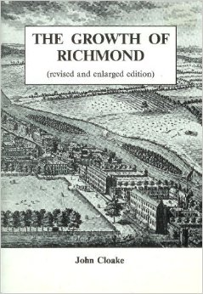

*John Cloake's book* The Growth of Richmond, *first published in 1982 and revised and enlarged in 1993*

I had discussed progress on these projects with a number of people, and in 1974 I was asked if I would give a talk on the History of Richmond to the Richmond Society. The talk was duly delivered on 25 February 1975. I had no slides but showed a few pictures pinned up on screens and three large plans of my own devising – one of the manor and its fields, one of the Palace and one of the Charterhouse. (These I subsequently deposited in the Richmond Library.) My first version of the Palace plan was published in 1982 in the first edition of *The Growth of Richmond*.

When another plan, for which Simon Thurley was largely responsible, was published later that year in Volume IV of the *History of the King's Works*, although there were some differences of detail I was glad to see that both were broadly on the same lines.

**Launching the Richmond Society's History and Archaeology Section**

The Richmond Society lecture proved truly seminal. In the questions session afterwards the lack of a local history society was raised – and the matter obviously aroused much interest. Another meeting was called soon after, specifically to discuss the establishment of such a body. It soon became clear that I was going to be asked to get it going. I was anxious that it should embrace both history and archaeology. The authorities of the Richmond Society were keen that it should be set up under their wing – and I was very ready to follow this idea, as it meant that we would be able to draw on the Society's resources instead of having to start everything up from scratch. And so the History and Archaeology Section of the Richmond Society was launched in April 1975, under my chairmanship.

I got a committee together. We drew up a constitution. George Cassidy, architect and Kew historian and a past chairman of the Richmond Society, agreed to be Hon. Treasurer. John Wright was Hon. Secretary. We launched the Section with a programme of six lectures in the season 1975-6. I asked John Harris, the architectural historian, to give our first lecture, on Sir William Chambers and his work at Kew. At the AGM in April 1976 I gave a talk on the Shene Charterhouse, on which I was then working up a lengthy article for the Surrey Archaeological Society's journal.

Another achievement of that first year was the publication of *Richmond, Surrey, As It Was*. The Twickenham History Society had just produced *Twickenham As It Was*, and it was Alan Urwin of that Society who suggested to me that such a book was an excellent way of raising some initial money for a publications fund. In return for the work of putting it together the publisher would pay a good royalty on all books sold. I got in touch with the publishers and a project was agreed. The work of selecting photographs from the Borough's collection and of writing captions for them was shared between myself, John Wright and Sally Albrecht. The book was published in October 1976 – and is still a source of income for our Society.

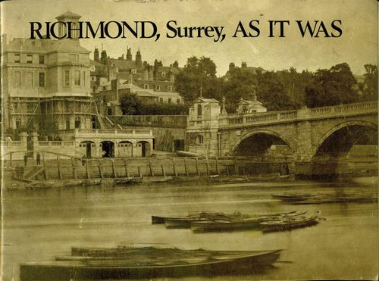

Before we got started on our second season I was appointed to be Ambassador to Bulgaria. I handed over the chairmanship to Tony Hoolahan, resigned from the committee, and set off. I took with me both a file of correspondence about the proposed article on the Shene Charterhouse (the final proofs of which shuttled back and forth between Guildford and Sofia via the Diplomatic bag) and photocopies of the whole of PRO documents LR3/71 and 72 (some 800 pages in all) – the 18th century transcription into English of the Richmond court rolls from 1603 to 1688, and the index thereto. I had had them specially copied to work on if I should find time on my hands in Sofia. I didn't – but they have been tremendously useful to me ever since.

In fact my Bulgarian project was Orthodox monasteries. My wife was working on a book on icons. My staff used to joke, "If you can't find the Cloakes, search the monasteries." Many of them were in remote hilly spots, usually by a stream – ideal picnic places. Some were of great architectural or artistic interest, others were just interesting as survivals, such as the small chapel with a solitary nun which we tracked down in the grounds of a lunatic asylum on the outskirts of Sofia.

I did however make two contributions to Richmond history while in Sofia. My article on the Shene Charterhouse was finally published in the Surrey Archaeological Collections in 1977. And I was in correspondence with Bamber Gascoigne over our respective collections of Richmond prints – and I was able to produce a few of which he hadn't known, to be added to his splendid *Images of Richmond* book.

**A Life of Field Marshal Sir Gerald Templer**

I came home on retirement in 1980, determined to write a definitive history of Richmond. Most of the previous books had largely borrowed from each other, with errors growing by repetition, and with never a source quoted. I wanted to work almost entirely from original documents, and to quote all my sources. But my intention of writing Richmond history was almost at once diverted. We had barely unpacked our things from Sofia when my friend Bill Reid, the Director of the National Army Museum, telephoned me. "My Field Marshal has died. His widow's looking for a biographer. I've told her you're the man." I started to demur – 'But Bill, I only met him once at that lunch at the Museum a couple of years ago – and I've never thought of writing a biography.' To cut a long story very short, he persuaded me at least to go with him to meet the 75-year-old Lady Templer. My wife will tell you that I fell in love with her on the spot. But the truth is that what she had to tell me about Sir Gerald Templer, his life and his achievements – and his character – persuaded me that he would be a splendid and most rewarding subject. Peggie Templer took her courage in both hands and asked me if I would do it. I took mine in both hands and said yes.

Sir Gerald did not leave a great mass of papers. What he had he had deposited in the National Army Museum, of which he had been the founder and until his death the Chairman of the Executive Committee. But it was evident that my main source would have to be people – and Peggie Templer was very good at suggesting contacts, providing addresses and so on. I spent about four years interviewing people – from Field Marshals and Prime Ministers down to a one-time batman – in Malaya and Ireland as well as all over England and Wales. The book was finally published in 1985. It got excellent reviews; but I had only just broken even on royalties over expenses when it went out of print.

**Chairing the Richmond Museum project committee**

I was still heavily involved with Templer research when I had a phone call early in 1983 from Diana Howard inviting me to join a small working party being set up to consider the possibility of creating a local history museum for Richmond. Now it was brought home to me recently that many local people (even members of this Society or of the Museum Friends) do not know, or have forgotten, about the origins of the museum, so I thought I would include some account of them.

Diana and I had several times discussed – and deplored – the lack of a local museum. The matter had been raised twice, in 1843 and 1881, but these proposals had come to nothing. The trigger now had been a talk between Pat Astley Cooper, the then Curator of the Orleans House Gallery (where a number of historic objects belonging to the Council were held in store), and Robin Wade, an architect specialising in museum design whose offices were then in Red Lion Street. Robin had taken the initiative to form this working party.

Some months later we had produced a project (my contribution was to sketch out the historical storyline and to suggest main points of interest to highlight in any display). Robin costed it all – and the total was absolutely forbidding. There was no way we could hope to raise the capital cost –and little hope of ever achieving a viable running operation without massive subsidy.

Nevertheless we decided to present our project to the good and the great of Richmond. Who knows, one of them might come up with a couple of million or so? We invited a carefully chosen bunch and asked Bamber Gascoigne to take the chair. Colin Dare offered us a room for the meeting at the Richmond Gate Hotel. The project was duly presented and the meeting agreed that a committee of citizens ought to be set up to pursue it, if at all possible. Bamber said, "A committee must have a chairman. John Cloake has coped successfully with the Bulgarian Government. He ought to be able to cope with the Richmond Council," – and I found myself Chairman of the Richmond Museum Project Committee. That was on 3 November 1983, just over 20 years ago.

**Launching the Richmond Local History Society**

Before going on with the Museum story, I should mention developments over the Richmond Society History Section. When I got back in 1980 I gathered that it had been through a crisis – as I wasn't there, I can't and won't elaborate – but George Cassidy (known to all as "Cass") was now in the Chair and had got it all back on an even keel, with Liz Velluet as the new Secretary and Jim Green as the new Treasurer. The archaeologists meanwhile had broken away and formed a new independent Archaeological Society, so we were now just the History Section. Cass asked me to rejoin the Committee, which I was glad to do.

We were having good programmes of lectures; we had launched *Richmond History* as our annual journal (if you *can* have a yearly daily!) which Stephen Pasmore successfully edited for 12 years; I had again given my talk on "The Growth of Richmond" and, suitably edited, it had been published as the Section's Paper No 1; we had instituted visits to local houses of interest and guided walking tours (many of which I led myself); and yet Cass and I and other members of the Committee were worried that however hard we tried we could not raise our membership much above the 100 mark. It was obvious that a limiting factor was that to be a member of the Society's History Section you had first to be a member of the Richmond Society. We had all come across people who said they would like to join the History Section, but not the Society. We resolved that we must declare independence. Cass said that while he fully supported this move, as a Patron and as a past Chairman of the Richmond Society he would prefer not to be the one who had to make it. He asked me to resume the chair, which I did at the AGM in 1984.

We didn't want a UDI situation. I wanted to negotiate a friendly separation with Paul Velluet, the Chairman of the Richmond Society. My text was "This isn't a divorce, it's just a grown-up child leaving home." And in that spirit we agreed – and the Committees, and then the AGMs, endorsed our amicable parting. The vote at the AGM of the History Section was unanimous. A few weeks later we launched the first meeting of the Richmond Local History Society. I had been elected as Chairman of the new Society and I had asked Bamber Gascoigne to give his talk on Richmond Prints. For the business part of the meeting I was sitting at a table at the front edge of the small stage in Meadows Hall. Bamber was opposite me in the front row of seats. I have no idea how it happened, but my table suddenly lurched over the edge, bounced on the floor and hit Bamber in the eye, breaking his glasses and cutting his eyebrow. With remarkable aplomb he just asked for a short break while he went home to get another pair of glasses – then gave his talk in a quite unruffled way. He offered his somewhat blood-stained handkerchief to the Museum!

I should add that within two or three months the membership of the new Local History Society had risen to at least twice that of the former History Section.

**A new museum at the Old Town Hall**

Very soon after the formation of the Richmond Museum Project Committee two important developments took place. The Liberals, who had recently won a majority on the Council, decided to back the Haslemere Estates plan for redevelopment of the Richmond Riverside site according to Quinlan Terry's designs. And it was then announced that, as part of this project, the former Richmond Town Hall would be renovated for use for "community purposes". Almost my first act as Chairman of the Committee was to write to the Town Clerk to say that we had a fully-worked up project for a museum, and might we have a floor of the Town Hall in which to realise it?

Three years of negotiation followed. I will not weary you with the details, but I will mention my first meeting on 25 March 1984 with the Councillor charged to head a sub-committee to consider the uses to which the Town Hall might be put – one David Blomfield. He made it clear that while the Council might be able to help over accommodation, there was no way they could meet the capital cost of setting up the Museum. I made it clear that unless we could be sure about the viability of the scheme as a going concern there was no point in trying to raise capital. Could the Council help both over accommodation and running costs? We both agreed that what was wanted was a really good museum, even if small, open to the public at least five days a week and with some professional staff.

The outcome of all the negotiation that followed was that if the Committee would raise all the capital required, and would undertake the future management of the Museum, the Council would let us have space in the Old Town Hall (for a licence fee of £1 a year), would pay for its lighting, heating and cleaning - and would subsequently meet the salary costs of a curator and

assistant – but this only after the Museum had been open to the public for two

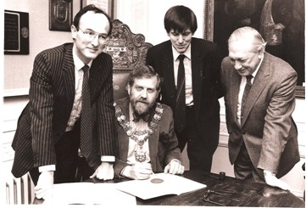

*John Cloake signs the Museum/Council agreement with Mayor David Cornwall*

years. It was the most I could screw out of them, but it was a start, and on the basis of it I was able to persuade the Richmond Parish Lands Charity Trustees to offer us a grant, spread over three years, which should enable us to employ a development officer/curator designate for a year or so before opening, and a curator and assistant for the two years after opening before the Council support for staff costs would become operative.

There was a final battle over space. It had been decided that the Central Reference Library, with an enhanced local studies section, would move into the building. Diana Howard, previously the strongest supporter of the Museum, now became our bitter rival for space. We had been pushed up to the second floor, but even so were not being given enough space for a viable layout. After consulting Robin Wade I laid down that we must have an absolute minimum of 1500 square feet or all bets were off. We ended up with a broom closet's worth over that figure.

Having turned the Committee into a Company limited by guarantee (of which I was now to be Chairman of the Board), we finally signed the agreement with the Council in December 1986. It gave us just fifteen months to raise sufficient capital to be able to confirm that the project would go ahead. I tried to form a small fundraising committee, but it fell flat on its face. I found a wonderful fundraiser. A month after we had started composing and issuing fundraising letters she told me she would have to give up as she and her husband were leaving the area. I spent most of 1987 doing the fundraising personally. I was certainly in part inspired by what I had found out and written about Gerald Templer's efforts in setting up the National Army Museum.

The fundraising campaign had two historical writings by-products. I produced a series of 32 short articles under the general title "Richmond Retrospect" for the *Richmond and Twickenham Times*, each one printed with an appeal for funds. Then, in an attempt – totally unavailing – to get some money out of Yale and Harvard and the Corporation of Richmond, Virginia, I wrote up articles about the people who linked them to our Richmond – turned shortly afterwards into my monograph on *Richmond's Links with North America*.

We needed to appoint as soon as possible a Development Officer/Curator. But at the end of December 1986 we had hardly enough funds to cover a month's salary. The Council and the Parish Lands Trustees agreed jointly to underwrite the salary for the post for one year. On that flimsy basis we secured the services of Kate Thaxton, young, bright and bubbly, but a very enthusiastic, dedicated and efficient first curator-to-be. It was she who first recruited and trained the volunteer helpers who were later transformed into the Museum's Friends.

The cost of setting up the Museum in the space allotted had been estimated at £80,000 to £100,000. We had at first to borrow from the capital fund to pay Kate, but at least we soon had enough to cover her salary for a year. However, we were under heavy pressure to get cracking as fast as possible. Every month that passed meant an extra month's expenses to be met before the Council's grant would become operative. The Museum Board decided that we could declare the project "go" as soon as we had raised two-thirds of the capital needed. We reached that point in December 1987 and so informed the Council and the Parish Lands Trustees. The latter's first year grant then enabled us to repay the capital fund.

We could now start designing the Museum in detail and we commissioned the Robin Wade Partnership to go ahead. At this point, unfortunately, I slackened off in my fundraising efforts. I was heavily involved in frequent meetings on museum design, in writing all the texts for labels and captions and information panels, in drafting maps, and in designing and drawing up the detailed plans and specifications for the two models that were to be a feature of the Museum – of the Palace and the Charterhouse.

Then we had two shocks. We had been led to believe that we would not be liable for VAT. This proved incorrect – you had to be registered for VAT to claim back as a charity any VAT on capital expenditure, but our expected turnover was far below the level for VAT registration. Then, once the tenders were in, it was obvious that, although we had by now successfully raised £100,000, the total cost, even without VAT, was going to be some 50% over the estimate. We cut what we could, postponing it to a "Phase 2 development". Mainly because of the VAT we were still £20,000 short. In desperation and so as not to lose any more time, my wife and I made a personal loan to the Museum. George Buckingham, our Treasurer, who was an experienced chartered accountant, eventually managed to persuade the VAT authorities to accept the "voluntary registration" of the Museum, so we got £15,000 of our loan back within a couple of years as the VAT on capital expenditure was reclaimed. The other £5,000 was desperately needed for much longer. I had agreed that our staff salaries should be equated to Local Government scales, but the latter had been increased significantly since we had told the Parish Lands Trustees what we thought we should need.

We had hoped to open the Museum at the end of September 1988, but it became apparent that we should need another fortnight. I had said jokingly that the obvious person to open a local museum was the Lady of the Manor – in our case the Queen! Then it was announced that the Queen had agreed to open the whole Riverside Development at the end of October. In agreement with the Mayor, Alison Cornish, I made a separate application to the Palace asking if she would open the Museum at the same time. This was agreed, so the Museum opening was postponed to the great day of 28 October. HM duly cut a ribbon in the presence of the Museum patrons, Board members, staff, architects and the Council representatives. It was five and a half years from the birth of the project, but less than two from signature of the Council agreement.

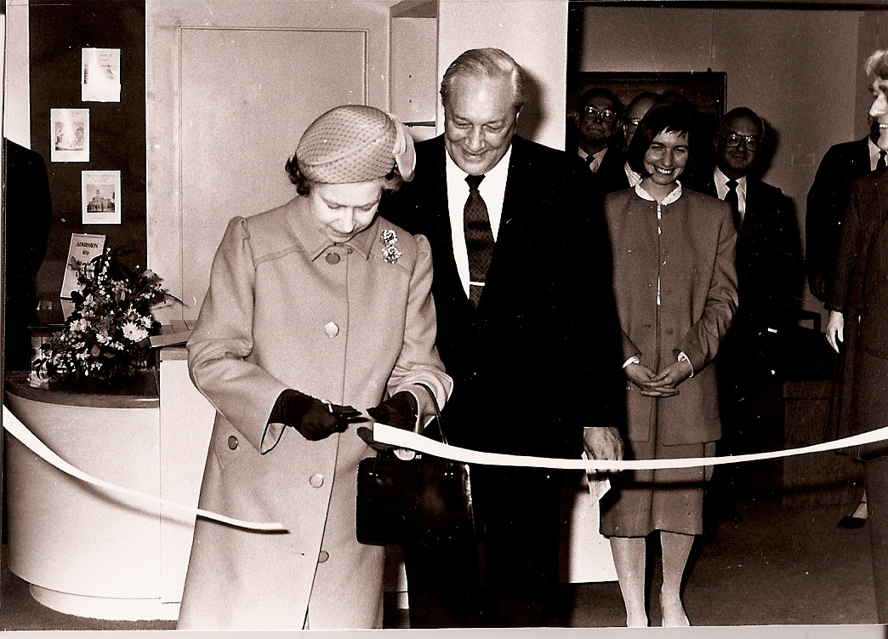

*Queen Elizabeth II (pictured with John Cloake) opens the Museum of Richmond*

**Research – from original documents**

By the late 1980s, with the Museum established and running well, first under Kate Thaxton and then her successor Simon Lace, with the new Local History Society a going concern, I was able at last to concentrate rather more on my own research. Though this involved occasional visits to the British Museum Library or the map room or the print room, to the Bodleian at Oxford, to other places such as the Museum of London, the Guildhall Library, the Surrey Archaeological Society Library at Guildford or the Surrey Record Office at Kingston, my principal sources were the Public Record Office (still with its older records at Chancery Lane) and the new Local Studies Room at the Richmond Library. And masses of books borrowed from that wonderful institution, the London Library.

I find it sad in a way that, although replaced by new and better facilities, three of these venues are no more. The great circular Reading Room of the British Museum Library and the North Room (where the splendid extra-illustrated copy of Manning and Bray's *History of Surrey* was to be found) were rather awe-inspiring. The Record Office at Kingston was cramped, but oh so much more convenient than a visit to Woking. What I really miss are the Round Room, the Long Room and the Rolls Room at the PRO. Writing out tickets for the documents you wanted was, if anything, quicker than ordering them on computer; they didn't take much longer to arrive (even if I hadn't, as I so often did, ordered them in advance by telephone). And if one was coping with an ancient roll there were proper tall easels to hang such things on while one turned the membranes. (I nearly got a heart attack a couple of years ago running back and forth along a large roll spread out over about 15 feet on two long tables at Kew, hunting for just one short passage of a few lines.)

There is something particularly fascinating to me in handling these old documents: record rolls or books (with disintegrating leather bindings done up in untidy parcels with string – but the same parcels now mostly served up concealed in neat cardboard boxes). When I unrolled some membranes of a parchment roll dealing with the manor of Shene at the exact time of the Black Death, I did feel a little nervous – but I'm still here to tell the tale.

Of course nearly all the documents prior to the 1730s are (apart from those of the Commonwealth period) in mediaeval Latin, but so many of the entries follow formulaic patterns that they are by no means as hard to decipher as they may at first appear. What is really difficult is when the handwriting is hard to read as well, the text is full of abbreviations and – sometimes – the ink is very faded. Some of the manor roll entries looked as if they had been scrawled out while the clerk was jogging on a donkey to hold the court at Petersham next day. Sometimes one just has to give up. Sometimes prolonged effort can bring results. The document of 1314 giving a survey of the manor of Shene was written in a very tight and tiny hand with a mass of abbreviations, but at least it was clear enough to enable me to have a photocopy made, over which I puzzled for weeks at home until I had finally cracked the whole thing. What a feeling of satisfaction that gave me! The document had never been published, not even mentioned, by any previous historian either of Richmond or of the manorial system (of which it was a prize example).

**Publishing**

I was giving quite a lot of talks at this time, in the late 80s, and apparently my reputation was growing as I was asked to perform to groups in say New Malden or Esher and at occasions such as conferences and courses at the Museum of London. At one of these I was chatting to another lecturer, John Richardson, who had been talking about Islington and Kentish Town. He said he had started publishing some highly-illustrated books about the history of London suburbs. He had written some himself. As he was only a one-man publisher he had got Phillimore's, the leading local history publisher in the country, to handle his marketing and sales. He asked if I would like to do a book on Richmond for this series. My wife Molli had frequently nagged me to produce a cheap popular history of Richmond, and I had said that I didn't want to spoil the market for my serious works when they were finally ready. But now I thought that if my name was already known to Phillimore's as a local history author, it might ease the way for publication of the weightier volumes to come. And so *Richmond Past* was born. It is just being reprinted for the fourth time, and is the only one of my works that has ever brought me any significant financial return!

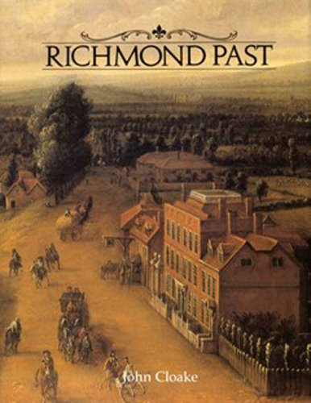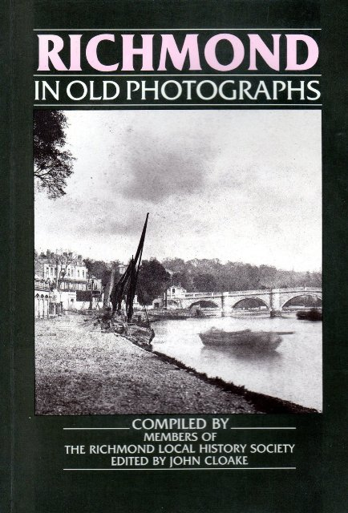

While I was working on *Richmond Past* I also had two other publications under way. My article on the Charterhouse of Shene was considerably expanded and further illustrated to be reprinted by the Local History Society as *Richmond's Great* *Monastery*. Then the publisher Alan Sutton asked me to do a *Richmond in Old Photographs.* I said I had too much on my plate to tackle it alone but I would edit it as a joint effort by members of the Local History Society. That was a mistake. Though my collaborators did excellent work, the net result involved me in more work than if I had done the whole thing single- handed. Both these were published in 1990, and *Richmond Past* in 1991.

When I was still in Sofia, Isador Caplan had written to me on behalf of the Parish Lands Trustees to ask if I would take on writing a history of the charity. I had declined at that time. Now I was approached again, by Isador and others. The charity had just celebrated its bicentenary and was on the point of opening up its area of benefit. The Trustees had been so helpful over setting up the Museum that I didn't think I could possibly refuse. The result was *Royal Bounty*, published by the Trustees in 1992. Two parts of the story were particularly interesting to research and to write: the early history of the workhouse, and the struggle in the 1960s between the people of Richmond (or a great many of them) and the Council over the redevelopment of the Queen's Road Estate.

In 1990 I thought that if I was ever going to get my major books on Richmond into print I should cut down on some of my commitments. I resigned as Hon. Treasurer of the British Institute of Persian Studies, a post I had held since 1982 – at a very difficult time, when just after the revolution in Iran our Institute building in Tehran managed to keep the flag flying even when the Embassy closed down completely. It had taken a lot of my time.

I also wanted to hand over the Local History Society. Richard Jeffree, a former Chairman of the Barnes and Mortlake History Society and a member of our committee for years since he moved to Richmond, was a very gifted amateur art historian, and also an active and extremely helpful member of the Museum Board. I had him in mind as my successor in both posts. I handed over the History Society to him at the AGM in May 1990. To my delight I was then elected President – a great honour which I still rejoice in.

But between then and the next meeting in September Richard had a serious stroke. He recovered to take charge, very successfully, of the Society for a year. Then in December 1991 as he was at work at home on a lecture on Richmond painters which he was due to give to the Society in January, he sneezed twice and expired. It was a great blow to us all – and a shock to me personally. I had to pinch-hit at the meeting, giving again some lecture I had done years before, and to take charge of the Society again until I persuaded Iris Bolton to take over the chair. With the help of his slides and some notes I was able to deliver what might have been Richard's lecture at a meeting in his memory a year later.

Richard had also been preparing for the Museum an exhibition of Thomas Rowlandson's topographical views of the Richmond area, and we went ahead with this as a tribute to him. It inspired me to suggest as another Museum exhibition the drawings and prints of Augustin Heckel – a gold chaser from Augsburg who came to London in the 1720s, and having made a great reputation and a small fortune for himself retired in the 1740s to live at the top of what is now Queen's Road, Richmond, where he amused himself by drawing the local scene. He was taken up in a big way by the print sellers who engraved many of his views. Molli and I had copies of most of those prints in our own collection. The aim of the exhibition was to bring together as many as possible of his original drawings (or photographs of several that, having been bought by Horace Walpole, were now in the USA) to be shown alongside the prints engraved from them. I also included material on his family (his father had been a goldsmith) and on his own works in gold (some are in the Victoria & Albert), and on some of his other artistic efforts – engravings of flowers, cartouches, a battle scene, etc. I count the catalogue which I wrote for this exhibition in 1993 as one of my pioneer works on Richmond history. At least the precious metals expert at the V & A ordered several copies, saying that nobody had ever put Heckel's life and works in gold and in graphics together before.

This had a curious sequel. In 1995 Sotheby's sent Simon Lace at the Museum a small transparency of a picture they were getting in from France. The owner said it was by an Anthony Heckel, dated 1749, and he thought it might be of Richmond. Simon shot it up to me. I rang Sotheby's saying, "Not only do I know more about *Augustin* Heckel than anyone else in Britain, having just mounted an exhibition on him, but the gentleman in this picture is walking out of my front door!" It was a view in gouache (a medium which I had never known that Heckel used) of the Terrace. It was signed A. Heckel and dated 1749. At the sale the Council tried to buy it but the bidding went too high. But I believe it is now in a private collection in Richmond. And a full-size colour photo of it hangs over my dining-room fireplace – a present from Sotheby's to thank me for my help in cataloguing. Over the years I've supplied information about Richmond pictures for Sotheby's, Christie's and Bonhams.

In the late 1980s and early 90s I was working quite hard on my major works, despite the interruptions of *Richmond Past* and *Royal Bounty*. I really did want to make my research available to others. I had decided that, rather than divide the subject in chronological slices (as my friend Richard Milward was doing with his history of Wimbledon), I would divide it thematically. First, because it was central to the whole story, I would deal with the royal history – the palaces and royal houses of Shene, Richmond and Kew, the several Richmond Parks, Richmond and Kew Gardens, the royal farms and the royal monastic foundations.

There was a lot of research still to be completed if I was to fulfil my objective of basing this history on documentary, not second-hand, sources. My greatest kick was when I dropped into place the last piece of my attempt to trace the origins of *all* the land enclosed into Richmond Park. I had found a lot in the close rolls, more in the manor records of Petersham and Ham, but then Raymond Gill, the historian of Mortlake, directed me to the Northamptonshire Record Office to find, scrawled in a rough draft, the relevant entries from the Wimbledon Manor records covering the Mortlake, Roehampton and Putney portions of the Park. Another excitement, again with an unexpected source, was when I learned that a lot of papers relevant to Kew had just been deposited in the Nottingham University Library. I rushed up there and worked for a couple of days on those still unaccessioned and unindexed family papers, discovering a lot of previously unknown material about the history of the royal houses at Kew.

By the late summer of 1992 I had, as I thought, completed my first major book, entitled *Palaces and Parks of Richmond and Kew*, and in October I took the typescript, in four fat files, down to Phillimore's office in Chichester. After some delay, the reaction was that they thought the book eminently worthy of publication and that they would like to publish it, but could see no way to do so unless there were an outside source of funding. I had produced a text of nearly a quarter of a million words, and was proposing some 350 illustrations, many in colour. It was beyond their resources, and could not possibly be a commercially viable proposition.

Both Phillimore's and I then tried to find a sponsor, but the only result was that I got an offer of a small grant towards the cost of the illustrations and the offer of an interest-free loan of £5,000 from the Parish Lands Trustees – welcome, but by no means a solution.

I then came up with an idea. The book could be split into roughly equal parts at about 1660 – which made sense historically. If these were published at, say, a year's interval people might recover from buying the first in time to invest in the second. And returns on sales of the first could help to finance the second. We worked out an agreement whereby I would advance half the production cost of Volume I. With the Parish Lands loan that would not be too painful. This advance, when recovered from pre-publication sales, would then be transferred to Volume II, hopefully to be repaid again (but this time to me) from pre-publication sales. But I would get no royalties on either volume until Phillimore's had fully covered their own costs. Volume I came out in November 1995, followed by Volume II in November 1996. They were very handsomely produced and I was delighted with them. I have just this year started to get some royalties on both volumes, so at least neither Phillimore's nor I are actually out of pocket on the deal.

All this time I had been continuing as Chairman of the Board of the Museum, and of its Trading Company, and as a Trustee. Though Simon Lace as Curator was doing a splendid job and was a delight to work with, I was beginning to find the continual meetings a bit of a strain and in any case I felt that I had now contributed about all I could (except for historical guidance as required) and that it was time for someone younger and with new ideas to take over. Richard Jeffree's untimely death had robbed me of my natural successor, but I determined that I would quit at the AGM in November 1995. Several people whom I approached as potential successors wriggled out of accepting, but then I turned to Martin Steel who had only taken over as Hon. Treasurer a few months before. It would at least be easier to find another new Treasurer than a new Chairman, and to my relief Martin agreed to step into the breach, taking over on 29 November 1995. To my surprise and delight I was immediately asked to become a Patron. So I remain involved, but more at arm's length.

**New experiences – and a surprise about Richmond Palace**

I was again honoured when, following the death of Diana Howard, I was asked in March 1997 to become President of the Richmond upon Thames Society of Voluntary Guides. 1997 brought two new experiences of interest. A researcher for Channel 4's *Time Team* programme had consulted me about the possibility of a programme on Richmond Palace. I suggested looking for the Tudor "privy lodgings" building in the lawn of Trumpeters' House. As this had been completely destroyed by 1660 there were no useful dimensions from Crown leases and, although I and the author of the plan in the *History of the King's Works* were in broad agreement as to its location, size and shape, this was only informed guesswork based largely on pictorial evidence.

By July 1997 all was agreed and the frantic three days digging and filming took place. I was involved throughout. I had suggested a first place or two to dig, based on my plan, but the geophysical survey had revealed some lines which everyone immediately assumed to mark the northern wall of the Privy Lodgings. I went along with this, though if I had thought about it more carefully I might have expressed doubts. The trenches revealed bits of brick and stone walls – or evidence of removal of stones – and a lot of brick dust. A few interesting objects were found such as window mouldings and bits of a ceramic frieze, but nothing really conclusive. The programme makers of course turned the whole thing into virtual certainty.

Then the Royal Commission on Historical Monuments, conducting a general survey of Carthusian monasteries in England, agreed with the Royal Mid-Surrey Golf Club that they could have a week in October to carry out a geophysical survey on the Shene Charterhouse site. An earlier much smaller survey in the corner of the Observatory grounds had revealed some lines and squares which – to my eyes at least – looked very like Carthusian monks' cells, in exactly the right place to be a corner of the great cloister as shown in my plan. This time the results were disappointing, perhaps because the weather was too good and the ground too dry. Apart from the scars in the grass, visible to the naked eye, that show the sites of some of the boundary walls that survived until 1771-2, there was no obvious sign of monastic buildings or even of the 17th century mansions that later stood on the site. Just one feature emerged really clearly – a small formal 17th century garden – and even that was not on the site where such a feature was shown on an 18th century plan!

In 1998-9 I worked with the photographers Graham Fletcher and Shelley Churchman on producing another book for Sutton's, *Richmond Past and Present*. This was based on an exhibition held in the Museum in 1996, but for the book many more scenes were recorded, with the old photographs combined with modern-day counterpoints, with text, captions and general editing supplied by me.

In March 1998 I was elected a Fellow of the London Society of Antiquaries, which pleased me a lot; but the big surprise of 1998 was a letter I received in late May from Florence. A Canadian art historian, Sabine Eiche, a specialist in Italian renaissance garden design, had come across in the Medici archives what she thought must be an early plan of Richmond Palace. I almost jumped on the next plane to Florence, but rapid exchanges of telephone calls and letters and then sight of a photograph of the plan established beyond question that it had been produced by Costantino de' Servi. He was the Florentine architect sent by the Medici Duke in response to a request from Henry, Prince of Wales, James I's eldest son, to whom Richmond had been granted as a residence. I already knew all about de' Servi's relationship with Henry, but here was the actual plan showing a completely new layout for the garden (involving considerable reclamation of land from the river) and some proposed alterations to the south front of the Privy Lodgings building.

These alterations to the building were confined to the addition of new wings at the south corners, with a loggia between them. But the really thrilling thing from my point of view was that the plan showed a detailed outline of nearly all of the then existing Privy Lodgings building, together with the bridge from it over the moat and an indication of how these fitted to the buildings in the centre court - the great hall and the chapel, for which we already had dimensions and fixed locations. And there was even a scale in English feet. The plan fitted well with the surviving pictures, so at last we had a means of completing a plan of the Tudor Palace to an accuracy of a few feet. The Privy Lodgings building turned out to be rather smaller than anyone had previously guessed, and located a little further west. (None of the *Time Team* trenches had been even near its outer walls.)

Sabine published her find in *Apollo* magazine in November 1998, but she kindly allowed me in advance to incorporate it in the draft of a lengthy academic article on which I was collaborating with Bob Cowie, a Museum of London Archaeological Service (MOLAS) archaeologist. This aimed to survey all that was known of the buildings of Richmond Palace, from both documentary and archaeological sources. It was completed by the end of 1998, but not actually published – in the journal *Post-Medieval Archaeology* – until 2001.

I had earlier been involved with MOLAS in the exploratory dig on part of the site of what is now the Tesco store when this was being redeveloped in 1994. On this my collaborator was Barney Sloane (both he and Bob Cowie are Twickenham residents). He did the digging. I provided a mass of historical material on the site. It was eventually published by MOLAS earlier this year, together with an article on Mortlake, under the title "Early Modern Industry and Settlement".

In the summer of 1999 I was interviewed by Prince Edward for a programme on Richmond for his *Crown and Country* TV series. This has evidently been shown – more than once – in the USA, as I keep hearing from friends there that they have seen me on TV.

Meanwhile I had been working away on my next big work, entitled *Cottages and* *Common Fields* (to balance *Palaces and Parks*), dealing with some economic and social aspects of the history of Richmond and Kew. It was nearly finished when, late in 1999, I was diagnosed as needing a major heart operation. I am very grateful to Ann Pearson for doing some final research for me while I was house-bound. I recovered, put the finishing touches to the typescript – nearly as long as the two volumes of *Palaces and Parks* put together, and took it to Phillimore's in June 2000. In the light of the slow sales of *Palaces and Parks* we agreed to restrict the print run to 500 copies. But this time the text did not split easily and Phillimore's did not want to try a two-volume approach. However, their calculations showed that for just 500 copies the production cost would be nearly £40 a copy (which by ordinary book-publishing arithmetic would mean a sale price of about £200). I decided that the only way to get the book into print would be to finance the whole process myself. On that basis Phillimore's were happy to handle the production and sales, and the book came out in November 2001.

At a pre-publication offer of £50 and a subsequent retail price of £75 it was hardly an instant best-seller! Why won't people pay for a book what they wouldn't think twice about spending on a couple of theatre tickets or a relatively modest restaurant dinner for two? Anyway, the main point for me was that I had now put into print the main results of my 40 years of research.

Incidentally, though the book was again beautifully produced, quite a number of small errors crept in which escaped my proof reading. If any owner of the book would like a list of corrigenda, I have some available.

I have recently completed, and lodged in the local studies room, my full analysis of the Richmond rate books from 1726 to 1771, locating every entry, which should make it much easier to trace houses and their occupants in that period. I produced a small monograph on Richmond Palace in 2001, to celebrate the 500th anniversary of the naming of Richmond. And I have just revised *The Growth* *of Richmond* for yet a third edition, launched today [8 December 2003].

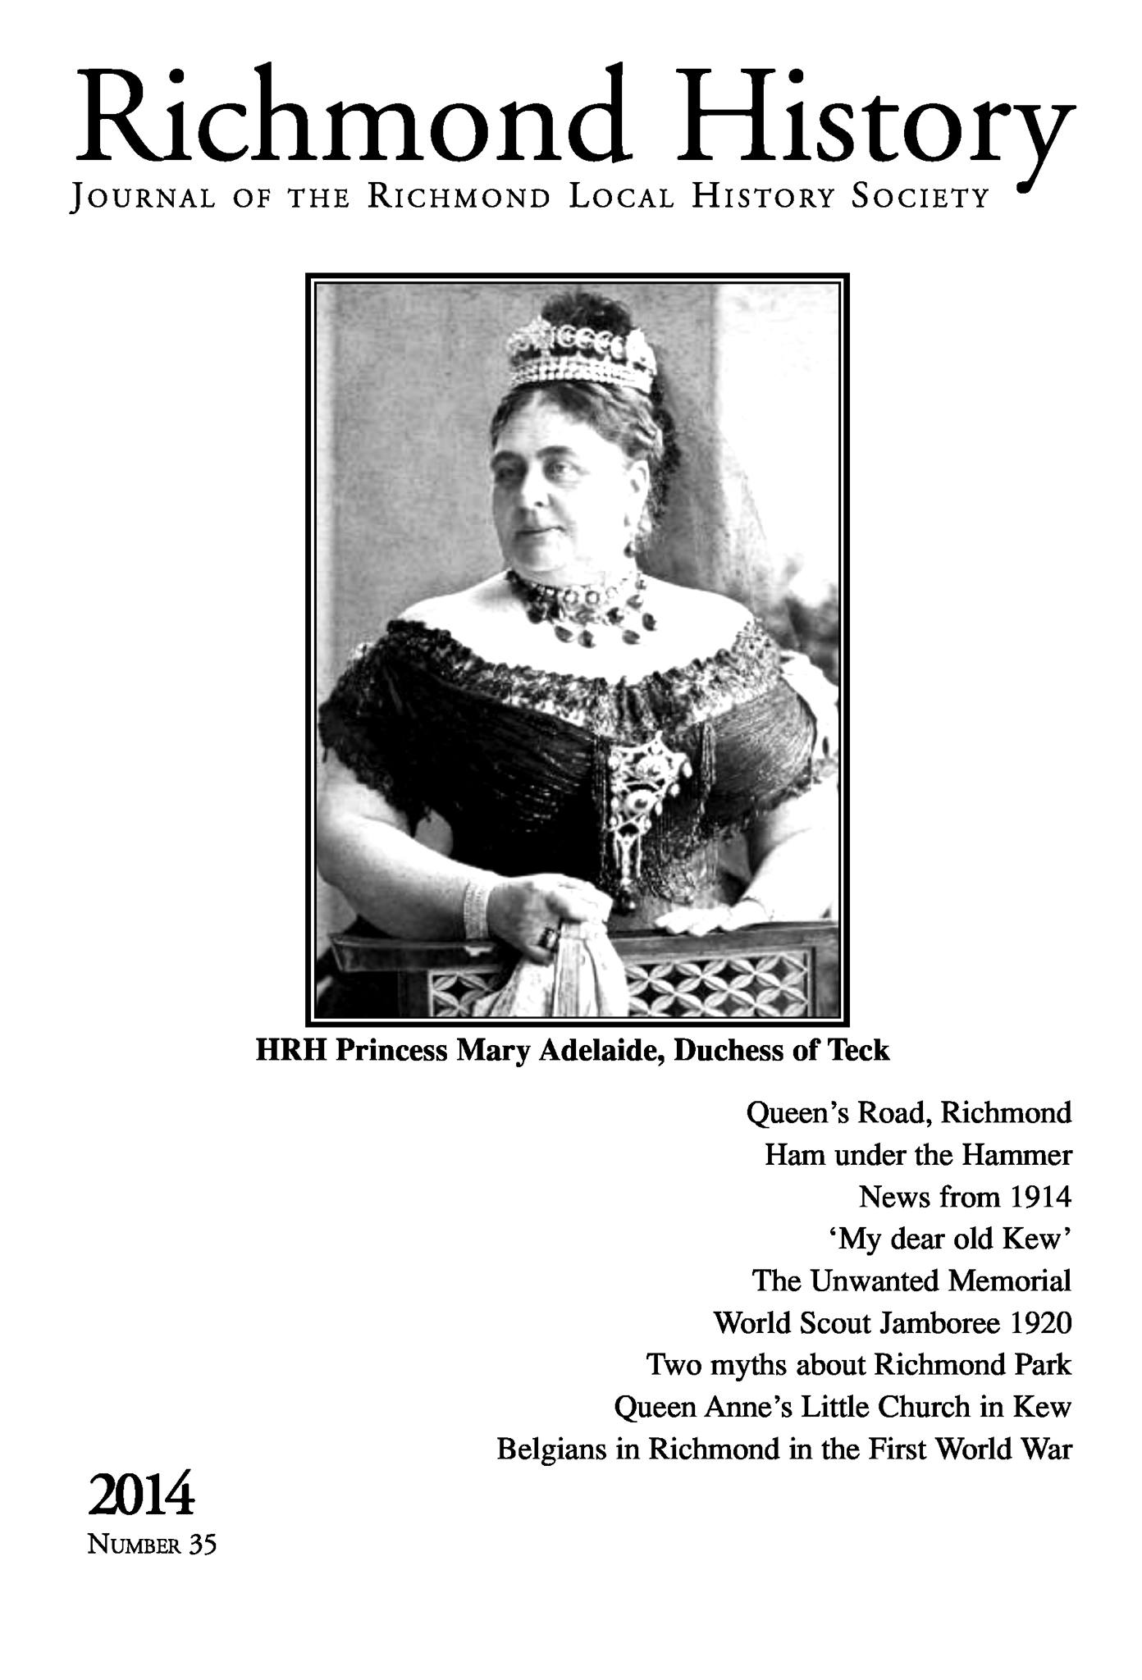

*The 2014 issue of the Society's journal* Richmond History *included two articles by John Cloake, published two months before his death*

Frankly I don't know whether I will ever now produce what I intended as the third part of a trilogy – on the architectural history of Richmond and Kew – but I have already written a lot on that subject. Anyway, I shall keep on enjoying local history as long as I can, writing articles (I haven't yet failed to have at least one in every issue of *Richmond History*), researching what interests me, identifying pictures, providing information for people who own historic houses in the town, and briefs for such bodies as the Environment Trust. I understand that a paper which I wrote for private circulation in 2000 on "The Destruction of Richmond's Historic Views" contributed towards the launch of the Arcadia project and to this year's very successful exhibition on "The View" (for the catalogue of which I wrote a historical introduction).

**Conclusion**

So when I look back over the 40 years since I started to research the Rosary, and recollect how in 1963 there was no local history society, no museum, and a relative dearth of accurate information on many aspects of Richmond's history, I am not altogether disappointed in my second career.

Of course other people have helped enormously. I cannot possibly mention them all. I owe the greatest debt to Molli my wife who for nearly all those 40 years has typed and retyped every word of my books and articles. I am a steam-age historian who still prefers to write everything in longhand. The help from the librarians Diana Howard and Jane Baxter and from the Museum curators and their assistants has also been vital. The Chairmen of the Richmond Local History Society – Richard Jeffree, Iris Bolton, Norman Radley and now David Blomfield – have made great contributions, as have the other officers and committee members (especially Liz Velluet).

And now there are so many more people researching and writing local history. I hope I have provided a sound basis for others to take up where I leave off. There is an enormous amount of material still to be explored and analysed and written up. Any of you, too, can "always write history later" – and I hope you will – but *do* base it on the documents!

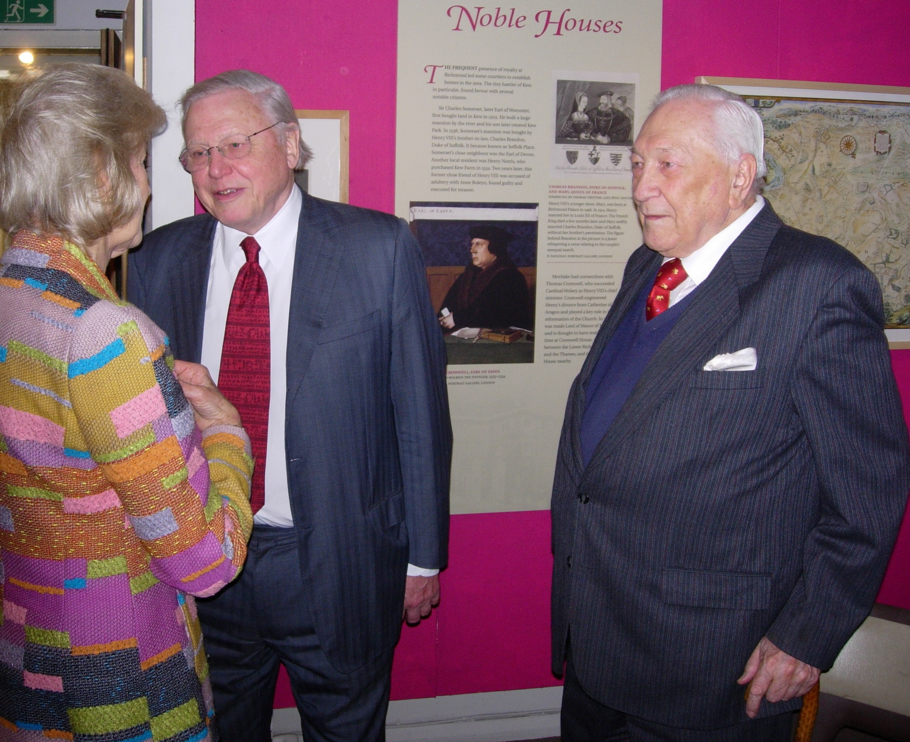

*John Cloake with HRH Princess Alexandra and Sir David Attenborough at the opening of the Museum of Richmond's exhibition* From Henry VII to Henry VIII in Richmond*, January 2009*

Photographs courtesy of

the Museum of Richmond

Published by the Richmond Local History Society July 2014